Dear Mrs. Geddes:

As you are aware of, the National Transportation Safety Board determined the 1-35 W bridge failed at the U10 truss joint. Our team then continued to review the evidence founded by the National Transportation Safety Board. We performed a Newton’s second law analysis on the structure, purpose being to determine if the collapse was due to a design flaw in the structure or due to additional weight. Mathematical analysis of the structure is as follows:

*F*BC(2) + *F*CG(0) + *F*GH(0) + *W*(0) + *W*(1) – 5/2*W*(1) = 0,

*F*BC = ¾*W*

The total force acting on joint C is roughly:

(*Fx* 2 + *Fy* 2)1/2 = (*F*BC 2 + *W* 2)1/2 = (25/16)1/2 *W* = 1.25*W*.

*F*AB = ¾*W*

The total force acting on joint A is roughly:

(*F*AB 2 + *F*AF 2)1/2 = [(3/4*W*)2 + (5/2*W*)2]1/2 = 2.61*W*.

The total force action on joint A is analogous to joint E.

As determined from the mathematical analysis, joint C, the joint at which the bridge failed, was bearing less weight than joints A and E. By this means, the bridge should not have failed at this point due to a design flaw. The thickness of the gusset was sufficient so it would not buckle under the weight of a normal live load; however, others factors came into play when further analyzing the collapse. For instance, in 1977 and 1998, the thickness of the deck was increased. We are unaware if the decking was evenly distributed. In addition, construction was occurring on the deck of the bridge, adding an additional 287 tons of a static load onto the U10 joint. Also, when studying the manner that the bridge failed, it is apparent that the additional weight caused the bridge to fail.

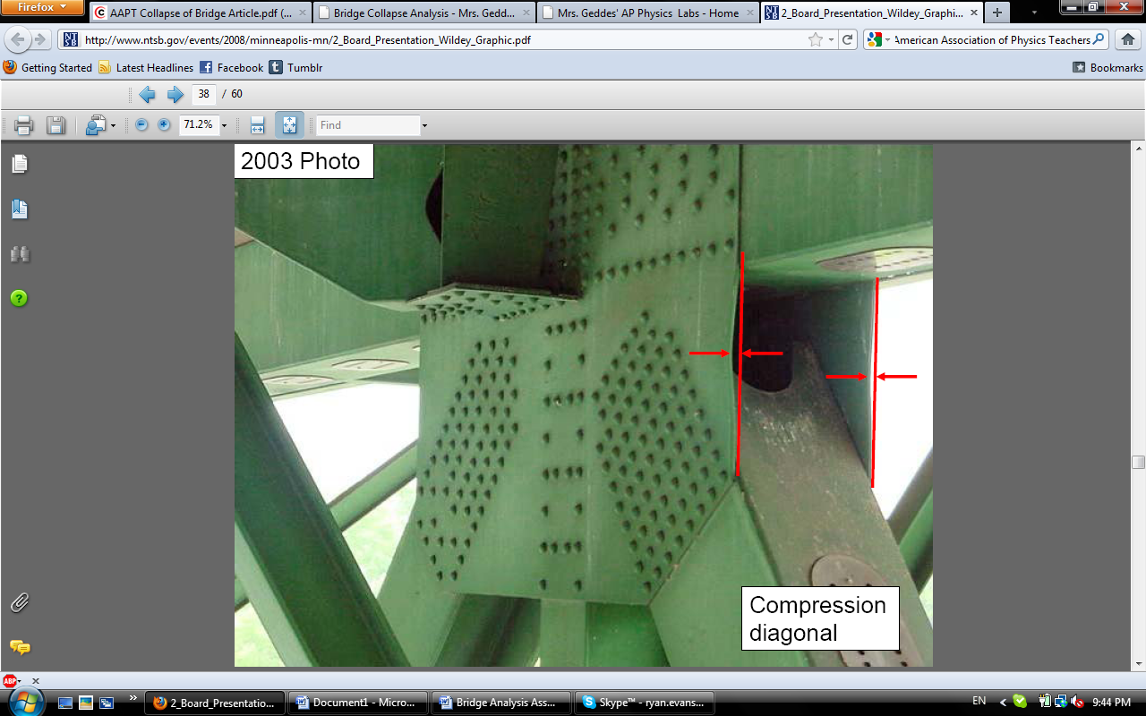

One can see that the gusset buckled, meaning the additional weight created extraneous pressure on the gusset. Because the bridge failed in this manner, it becomes apparent that the initial design of the bridge did not cause the failure; however, when adding the extra decking, an increase in the thickness of the gusset would have prevented the failure of the bridge because buckling would be less likely to occur.

Our team thanks you for the opportunity to analyze the collapse of this bridge. We hope that the information presented in the letter has helped the GeddesPhysics Laboratory Memorandum come to a conclusion regarding the failure of the I-35W bridge structure.

Yours Sincerely,

Ryan Evans

*Failure Modes Analysis Team*

Sources:

<http://sz0136.wc.mail.comcast.net/service/home/~/AAPT%20Collapse%20of%20Bridge%20Article.pdf?auth=co&loc=en_US&id=173160&part=3>

<http://www.ntsb.gov/events/2008/minneapolis-mn/2_Board_Presentation_Wildey_Graphic.pdf>